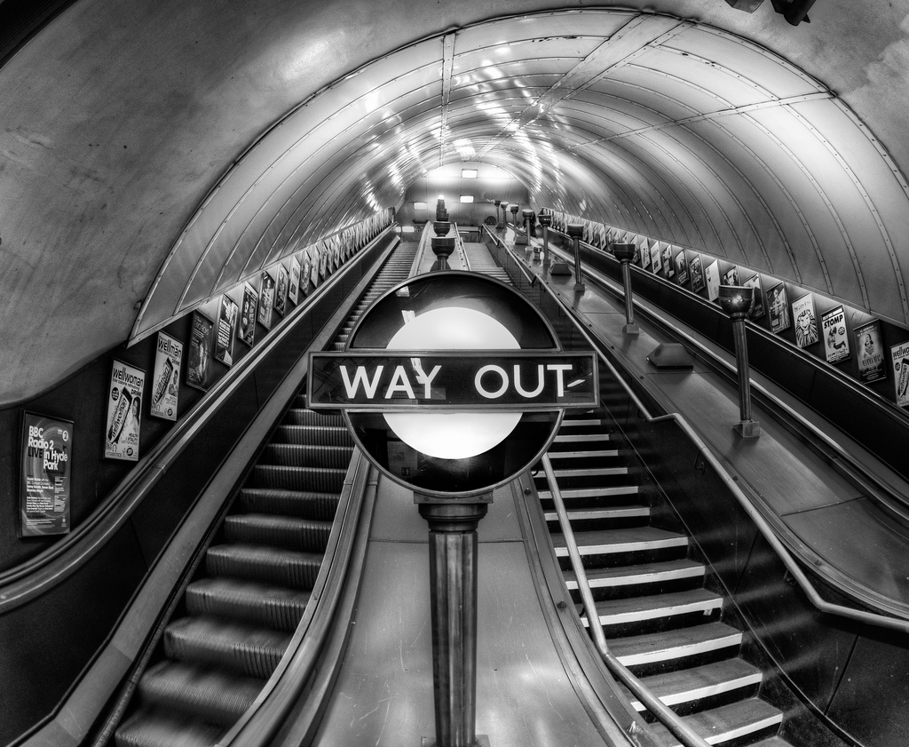

Black and white can be used in photos to force emphasis on a subject, remove colors that would be blown out on a clear sunny day, or as in this case, it can be used to give a photograph a more vintage feel. In Britain they do not have exit signs, but use "Way out" signs instead. This one almost has a feeling of a 1950s diner. The font on the sign, curved lines, and numerous advertisements spaced evenly up the walking paths draw your eye up to the top of the image, but force you to stop and look at the subject keeping your eyes from running off the side of the image. This is important as there really isn't much of anything keeping your eyes from running off the edge other than the lack of textures and subject matter in the background and a prominent subject in the foreground.